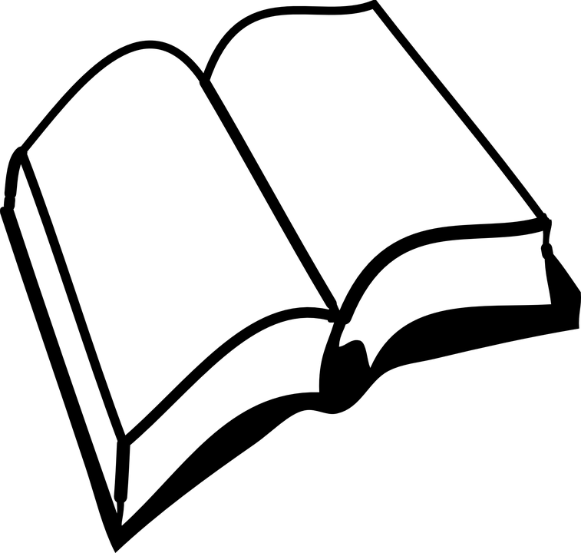
Independent Reading Assignment

NOVEL EXPECTATIONS

Everyone has his or her own individual preferences when it comes to choosing what to read. Science fiction, mystery, romance, fantasy, horror, real-life are just some of the many genres of books that are available to you. This is an independent novel project, so you get to choose what you want to read. Of course, I will happily provide suggestions and even help you pick out a book – just ask! Even though you have a lot of freedom in your choices, I ask that you follow these simple requirements:

• The novel should be fiction. Non-fiction, while fantastic in itself, is difficult to complete the tasks with. If you really want to read a non-fiction piece for your project, see me in advance.

• Challenge yourself. Choose something different perhaps, or maybe a novel that is a little bit more difficult than what you would normally read. Take a chance – you just may like it!

• You must take initiative to find your own novel and follow the due dates. I will always be available to guide you and answer any questions, but you will need to be responsible.

•Complete the pre-reading activities to finalize your book selection.

Each student will complete an a reading assessment package that will include the following three components

1)Vocabulary Assignment

Choose 5 words from your novel
-write the word
-write the complete sentence from the novel using correct referencing (ie page # and quotations)
-write what you think the word means
-write the dictionary meaning of the word

2)Summary Assignment

Write a one page summary of what you have read this week. Be concise and provide main details of the plot and your thoughts/reflection on how your reading is progressing.

3) Focus Question of the Week- one page response to list of questions below

Week 1: Describe the main setting of the book. How does the setting set the mood for the book. Write down three or four descriptive sentences that appeal to you and describe why.

Week 2: Analyze the characters. Describe their physical characteristics and personality traits. Explain why you would want to be friends or not with one of these characters.

Week 3: What is the plot? Explain the conflict or goal of the story and/or how the characters are trying to solve or achieve it. Make a prediction of how the story might change or of something that may happen next.

Week 4: What is a theme? Write about a connection to another book you have read (think about similar characters, plots and settings). Describe an experience you or someone else you know that was like an experience a character of a character in a book.

Independent Reading Rubric
 | Level 1 | Level 2 | Level 3 | Level 4
Ideas/Content  Does your work reveal that you have thoroughly read the novel and you understand the elements within the novel? | demonstrates poor comprehension of text excluding details from the text and no examples of setting, events characters, and literary elements | demonstrates limited comprehension of text using details from the text missing examples of setting, events characters, and literary elements | demonstrates comprehension of text using details from the text and includes some examples of setting, events characters, and literary elements | demonstrates excellent comprehension of text using details from the text and includes examples of setting, events characters, and literary elements
Reading Strategies  Do you make clear connections between the novel? Do you specifically reference the novel, make, predictions, infer happenings and/or summarize the main details? | Demonstrates no thoughtful analysis. Lack of inferencing and connections to story.  Developing reading strategies. | Demonstrates a somewhat thoughtful analysis; some connections made. Limited inference to story elements.  Limited use of reading strategies. | Demonstrates some insight and thoughtfulness in analysis. Connections are evident. An effort to infer and relate to characters and situations is evident.  Good use of reading strategies | Demonstrates very insightful and thoughtful analysis; connections are very relevant and clearly communicated. A, strong ability to infer, relate to characters and situations. Strong use of reading strategies.
Sentence Structure/  Conventions  Does your written work communicate clearly and effectively? Is your writing detailed? Do you use appropriate grammar, spelling, and punctuation? | Organization is not clear. Sentences are repetitive and nonsensical. Lack of editing is distracting to reader. | Limited organization is evident. Sentences are repetitive and lack fluidity. Lack of consistent editing is distracting to the reader. | Some organization is evident. Sentences are well written and non repetitive. Only minor editing oversights | Organization is very clear. Sentences are thoughtful, non repetitive and of high quality. Spelling and conventions have been effectively edited.
Creativity  Do you use personal creativity?Do you add your own interest and flare to the assignment? Have you put in a lot of thought and care? | There is little evidence of creativity in the project. The creator does not demonstrate much imagination. | contains some creative details and/or descriptions, but they distract from the project. The creator has tried to use his imagination. | contains adequate creative details and/or descriptions that contribute to the viewers enjoyment. The creator has used his/her imagination. | contains many creative details and/or descriptions that contribute to the viewers enjoyment. The creator has really used his/her imagination.

