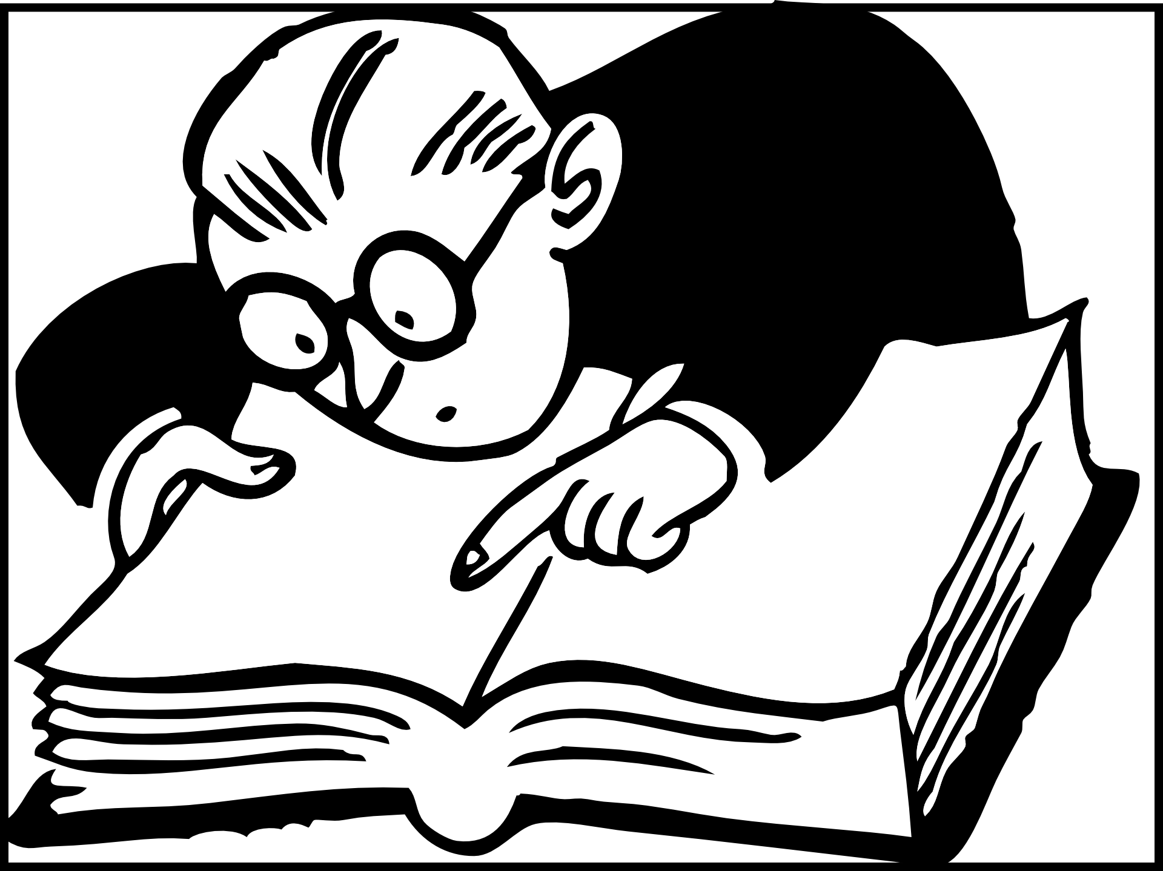
Reading Assessment

This month you will be focussing on applying the reading strategies we have been studying to your independent reading novel. While reading your novel, be conscious of Inferring, Connecting, Visualizing, Synthesizing and Determining Importance to the events, characters and story elements. You will answer ONE question from each section below. Each answer should be btwn ½-1 page in length. Be sure to include evidence from the text to support your answer.

Inferring
- How do you think the main characters feels at the end of the story What are some clues that made you think this?

- Give examples from the story of when a character displayed different emotions?

- How did the characters actions help you to understand how he or she was feeling?

- Pretend you are one of the characters. Write a letter to someone describing what has happened so far, how you are feeling, and what you think might happen next.

Determining Importance
- Describe three character traits of one character from the book. Provide evidence from the book that demonstrates each character trait.

- What was the main problem or conflict that a character faced in the story? How was the problem or conflict resolved? Do you agree with how the problem or conflict was resolved? Explain why you agree or disagree with the solution to the problem

- What are the three most interesting things you learned from reading the story? Tell why you think these parts were appealing to you.

- Write the main ideas of the story. Make sure you include plot, characters and theme Is there a lesson or moral from the book?

Synthesizing
- Retell the story from another character's point of view

- How would the story have been different if one of the characters were changed in some way?

- If you were an author, what would you have changed in the book? Perhaps you might have changed a character or the ending- How would the story have been different?

- How do you think the story would change if a character in the story made a different decision or choice?

Visualizing
- Choose a particularly descriptive passage of the book. Record things you were able to visualize as you were reading, what did you think about? Use as many of your sense as you can.

- Create a magazine advertisement to promote the book. Remember to include title, author, an illustration and an interesting caption about the book.

- If you were in charge of turning the book into a movie, which celebrities would you have play the different characters? Describe why you think each celebrity is best suited to portray that character.

- Draw a visual image of your novel. Include evidence from the text that supports your picture.

Connecting
- What does this story remind you of?

- How is this book similar to one you have read before, explain in which ways they are similar.

- Select a character in the book that is similar to you. Explain the similarities, remember to use examples from the text and your own life.

- Create a Venn Diagram to compare this book and another one you have read on a similar topic or by the same author.

