Cells Unit

Day | Lesson | Materials
1 | Introduction to Cells  Watch intro video on cells  Students play game of kahoot to see what they know. 10 mins  Brainstorm the definition of Cell & Atoms  Handout atom & Cell worksheet for students to complete and discuss. Ensure they justify their answer in the why section with valid detail.  * Students prepare notebook for unit. Title page, Table of Contents etc | Intro to cells video https://youtu.be/gFuEo2ccTPA  www.kahoot.com  Atom & Cells Worksheet
 | Characteristics of Living Things  Living vs Non Living  Students read and copy main pints into notebooks. Students work to complete the worksheet to completion. | Living vs Non living handout
2 | Living Things & Cell Theory  Students read and copy main points into notebooks.  Handout Interactive Intro to Cell Theory sheet for students to complete. *May be teacher or self directed (links included) | Living Things & Cell Theory Note  Introduction to cell Theory Interactive worksheet
3 | Organelles  Organelle Video  Handout Organelle Reading, students highlight main points and fill in organelle chart.  Students mix and match Organelle Matching Cards  As consolidation see if students can answer the organelle riddles | Youtube: Biology: Cell Structure https://youtu.be/URUJD5NEXC8  Organelle Reading  Organelle Chart  Organelle Matching Card  Organelle riddle sheet
4 | Microscope  How to use a Microscope  Parts of a Microscope  Preparing a dry Mount activity | How to use a microscope information sheet  Parts of a microscope diagram  Preparing a dry mount Specimen Activity sheet  Dry mount Observation Recording sheet
5 | Plant and Animal Science Lab Activity  Students will explore plant cells through a onion specimen and a animal cell through a cheek cell lab activity | Plant cell lab instructions  Animal Cell lab instruction
6 | Cell Processes  Students learn the specific roles cells have in a system. Students read and highlight Cell process reading.  Students complete quick quiz to check for understanding | Cell Processes Reading  Check for understanding quiz
6 | Cell Respiration  Students read article describing cell respiration and complete the questions | Cell respiration reading  Cell respiration questions
7 | Cell Reproduction  Watch video on Mitosis  Mitosis article and questions  Students draw or visually re create the cell stages of mitosis. | Youtube video: Mitosis https://youtu.be/L0k-enzoeOM  Cell cycle & Meiosis https://youtu.be/woD6zvp-4E8  Drawing mitosis worksheet  Cell Mitosis FLipbook
8
5558

Name:_____________________
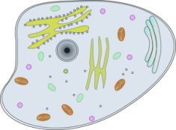
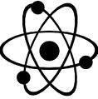
Atoms and Cells

In each set, circle the Odd One Out, and describe why it does not fit with the others.

A. Which is the Odd One? | Why is it the Odd One Out?
Leaf of a plant
Horse’s muscle
Blood
Sugar

B. Which is the Odd One? | Why is it the Odd One Out?
Piece of metal
Apple seed
Olive oil
Diamond necklace

Thinking about the two groups above, which of the following statements best describes both groups? Explain.

- Both groups are made up of cells.  - Both groups are made up of atoms.  - Group A is made up of cells and Group B is made up of atoms  - Except for “the odd one out”, Group A is made up of atoms only, and Group B is made up of cells and atoms.  - Except for “the odd one out”, Group A is made up of cells and atoms, and Group B is made up of atoms only. | Why?

Which is bigger, an atom or a cell? APE your answer (Answer, Prove, Extend)

Living vs Non Living

The World is made up of both living and nonliving things. The term living applies to anything that is or once was alive. Nonliving applies to something that was never once alive. In order for something to be classified it must grow, develop, use energy, reproduce, produce waste, made of cells, respond to its environment and adapt. While many things meet one or a few of these criteria, a living thing must meet all criteria.

Sort the items below into the proper category

Living | Non Living

Pine Tree, Wind, Volcano, Molecule, Shell, Fungus, Zombie, Algae, Human, Bacteria, Hair, Water, Sun, Coral

Some objects can do many of the things that living things do. But, unless they do all characteristics, they are not living. With a partner, think about a car. A car can move, a car needs energy, a car makes waste, a car cycles the air inside it, and a car can even react to things (alarms). So, why is it not alive? Explain your answer.

Characteristics of living things:

1. Composed of Cells 2. Require Energy 3. Grow/Repair Itself

4. Reproduce 5. Breathe 6. Capable of Movement

7. Produce Waste 9. Have a Life Span 10. Respond to their Environment

Living Things & Cell Theory

The cell is the simplest organic structure that can carry out activities of a living thing. Since most cells are too small to see with the unaided eye. The existence and structure of cells remained unknown until the late 1600s. Anton Van Leeuwenhoek designed the first successful light microscope. He made tiny lenses that magnified the object 270x. He was the first to see bacteria cells, yeast cells and blood cells. 1830’s. Mathias Schleiden identified the first plant cells and concluded that all plants are made of cells.

Overtime scientists developed 3 basic assumptions about cells and living things:

- The cell is the basic building block of life
- An organism can be as simple as one cell (unicellar) or it can be made up of trillions of cells (multicellular)
- All cells are created from existing cells through a process called cell division. Living cells do not simply appear out of thin air.

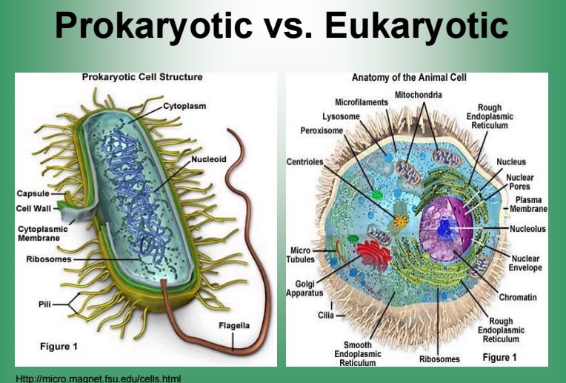
Cells can be Eukaryotic or Prokaryotic

•Prokaryotes: do not have a nucleus or
organelles (bacteria).

•Eukaryotes: have a nucleus and
organelles (plants, fungi, animals, protists).
Two types of Eukaryotic cells are animal and plant cells.

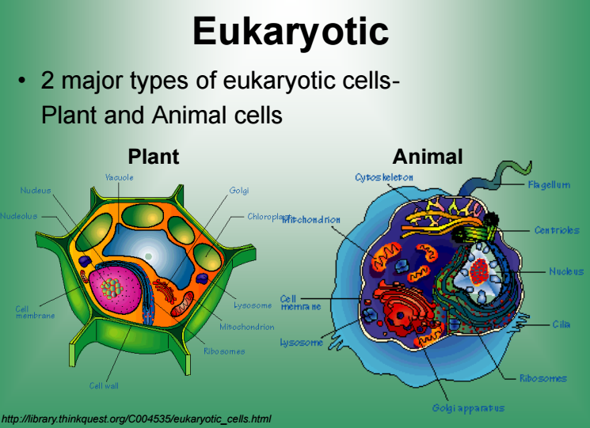
Modern day scientist have since expanded the cell theory, adding the following inclusions:

4) Energy flow occurs within cells
5) Hereditary information(DNA) is contained within cells
6) All cells have the same basic chemical composition

Introduction to Cells & Cell Theory
Interactive Activity

After learning about the cell theory, there are three specific components we will look at more closely, students will watch the following clips and respond below.

- Cells are the smallest unit of structure and function of living things,
Watch the video: Levels of organization https://youtu.be/ZRFykdf4kDc and answer the following focus questions:

- Why do they compare the building of city to that of a human body? In a human body what is analogous to the bricks in a city)

- According to the video what are the smallest part of living things?

- Write down some examples of human cells.

- Fill in the following sequence : cells > _________ > organs > __________ > organism.

- Without bricks it would be very difficult to build and repair a city. What do you believe would be the outcome if living things had no cells.

- Cells come from pre-existing cells
Watch the video: Cells dividing https://youtu.be/XdKvdURrtDs. Sketch what you see on the clip.

- All organisms are made of one or more cells,
Look at the following picture and answer the questions below.

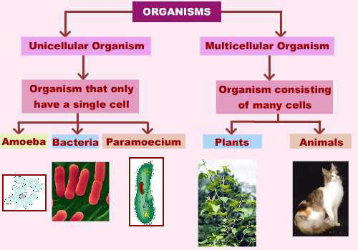

- Based on the picture above what are the two type of organisms that exist?

- Are plants and animals multicellular or unicellular? What does it mean to be multicellular?

- Could you infer from the figure that bacteria are living? Why do you think this?

Unicellular Organisms Research Activity

Unicellular organisms are composed of a single cell, unlike multicellular organisms that are made of many cells. This means that they each live and carry out all of their life processes as one single cell. Most unicellular organisms are microscopic; however, some are visible to the naked eye.

Students will select one unicellular organism below.
Amoeba Paramecium Euglena
Diatom Chlamydomonas Stentor

Students will have 15 minutes to quickly research:
– How does it move – How does it get energy – Find a microscope image

When time is up, Students will give a quick 3 minute explanation on their unicellular organism.

Cell Organelle Reading

All living organisms on Earth are divided into cells. The main concept of cell theory is that cells are the basic structural unit for all organisms. Cells are small compartments that hold the biological equipment necessary to keep an organism alive and successful. Living things may be single-celled or they may be very complex such as a human being.

There are smaller pieces that make up cells called organelles. In larger organisms, the main purpose of a cell is to organize. Cells hold a variety of pieces and each cell type has a different purpose. By dividing responsibilities among different groups of cells, it is easier for an organism to survive and grow.

Plant cells are easier to identify because they have a protective structure called a cell wall made of cellulose. Plants have the wall; animals do not. Plants also have organelles such as the green chloroplast or large, water-filled vacuoles. Chloroplasts are the key structure in the process of photosynthesis.

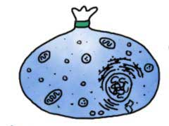
Cell Membranes
According to cell theory, cells are the main unit of organization in biology. Whether you are a single cell or a blue whale with trillions of cells, you are still made of cells. All cells are contained by a cell membrane that keeps the pieces inside. When you think about a membrane, imagine it is like a big plastic bag with some tiny holes. That bag holds all of the cell pieces and fluids inside the cell and keeps any nasty things outside the cell. The holes are there to let some things move in and out of the cell.

Different Membranes of the Cell
As you learn more about cell organelles, you will find that they all have a membrane. Organelle membranes do not have the same chemical makeup as the cell membrane.
Some organelles have two membranes. A mitochondrion has an outer and inner membrane. The outer membrane contains the mitochondrion parts. The inner membrane holds digestive enzymes that break down food.

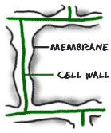
Cell Wall - What's it for?
Cell membranes surround every cell you will study. Cell walls made of cellulose are only found around plant cells and a few other organisms. Cellulose is a specialized sugar that is classified as a structural carbohydrate and not used for energy. If a plant cell is like a water balloon, the cell wall is like a cardboard box that protects the balloon. The balloon is protected from the outside world by a structure that provides protection and support.

Cytoplasm - Filling Fluid
Cytoplasm is the fluid that fills a cell. There is special fluid in the mitochondria, endoplasmic reticulum, Golgi apparatus, and nucleus. The only two 'plasms' left are cytoplasm (the fluid in the cell also called cytosol) and nucleoplasm (the fluid in the nucleus). Each of those fluids has a very different composition.

Cell Nucleus - Commanding the Cell
The cell nucleus acts like the brain of the cell. It helps control eating, movement, and reproduction. If it happens in a cell, chances are the nucleus knows about it. The nucleus is not always in the center of the cell. It will be a big dark spot somewhere in the middle of all of the cytoplasm (cytosol).

Chromosomes - Pull up Those Genes
Chromosomes are the things that make organisms what they are. They carry all of the information used to help a cell grow, thrive, and reproduce. Chromosomes are made up of DNA. Segments of DNA in specific patterns are called genes.

Ribosomes - Protein Construction Teams
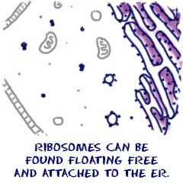
Cells need to make proteins. Enzymes made of proteins are used to help speed up biological processes. Other proteins support cell functions and are found embedded in membranes. Proteins even make up most of your hair. When a cell needs to make proteins, it looks for ribosomes. Ribosomes are the protein builders or the protein synthesizers of the cell. They are like construction guys who connect one amino acid at a time and build long chains.
Ribosomes are found in many places around a eukaryotic cell. You might find them floating in the cytosol. Those floating ribosomes make proteins that will be used inside of the cell. Other ribosomes are found on the endoplasmic reticulum. Endoplasmic reticulum with attached ribosomes is called rough ER. It looks bumpy under a microscope. The attached ribosomes make proteins that will be used inside the cell and proteins made for export out of the cell.

Mitochondria - Turning on the Powerhouse
Mitochondria are known as the powerhouses of the cell. They are organelles that act like a digestive system which takes in nutrients, breaks them down, and creates energy rich molecules for the cell. The biochemical processes of the cell are known as cellular respiration. Many of the reactions involved in cellular respiration happen in the mitochondria. Mitochondria are the working organelles that keep the cell full of energy. Mitochondria are small organelles floating free throughout the cell. If a cell feels it is not getting enough energy to survive, more mitochondria can be created.

Chloroplasts - Show Me the Green
Chloroplasts are the food producers of the cell. The organelles are only found in plant cells. Animal cells do not have chloroplasts. Chloroplasts work to convert light energy of the Sun into sugars that can be used by cells. The entire process is called photosynthesis and it all depends on the little green chlorophyll molecules in each chloroplast.

Endoplasmic Reticulum - Wrapping it Up
Another organelle in the cell is the endoplasmic reticulum (ER). While the function of the nucleus is to act as the cell brain, the ER functions as a manufacturing and packaging system. Structurally, the endoplasmic reticulum is a network of membranes found throughout the cell and connected to the nucleus. The membranes are slightly different from cell to cell and a cell’s function determines the size and structure of the ER.

Golgi Apparatus - Packing Things Up
The Golgi apparatus or Golgi complex is found in most cells. It is another packaging organelle like the endoplasmic reticulum (ER).

Vacuoles - Storage Bins to the Cells
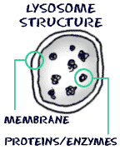
Vacuoles are storage bubbles found in cells. They are found in both animal and plant cells but are much larger in plant cells. Vacuoles might store food or any variety of nutrients a cell might need to survive. They can even store waste products so the rest of the cell is protected from contamination. Eventually, those waste products would be sent out of the cell.

Lysosomes - Little Enzyme Packages
You will find organelles called lysosomes in nearly every animal. Lysosomes hold enzymes that were created by the cell. The purpose of the lysosome is to digest things. They might be used to digest food or break down the cell when it dies.
A lysosome is basically a specialized vesicle that holds a variety of enzymes. The enzyme proteins are first created in the rough endoplasmic reticulum. Those proteins are packaged in a vesicle and sent to the Golgi apparatus.

Cell Organelles

Cell Organelles On the back of this page you will find an image of both a plant and an animal cell. These cells are labelled with letters. Using those images, and the supplied readings, fill in the chart below.

Organelle Name | Plant Cell or Animal Cell | Function
Nucleus

Chromosomes

Cell Membrane

Cell Wall

Cytoplasm

The Vacuole

Chloroplast

Mitochondria

Ribosomes

Endoplasmic Reticulum

Golgi Apparatus

Lysosomes

Cell Organelle Riddles
Read each description below and then identify the correct cell structure. Write your answer in the line provided using only 10 of the following words:

Golgi apparatus Cell membrane Endoplasmic Reticulum Cell Wall
Chloroplast Nucleus Vacuole Chromosomes (DNA) Ribosomes Lysosomes Mitochondria

1. I’m a real “powerhouse” 6. I’m a series of tubes
That’s plain to see Found throughout the cell
I break down food I transport proteins
To release energy. And other things as well
What am I? What am I?

2. I’m strong and stiff 7. I’m full of holes
Getting through me is tough Flexible and thin
I’m found only in plants I control what gets out
I’m what makes sticks tough As well as what comes in
What am I? What am I?

3. My name means coloured bodies 8. Proteins are made here
And I contain DNA Even though I’m quite small
I pass on traits to new cells You can find me in the cytoplasm
In a systematic way Or attached to the ER’s wall
What am I? What am I?

4. I’m the brain of the cell 9. I’ve been called the storage tank
Or so they say By those with little taste
I regulate activities I’m a sack filled with water,
From day to day Food, enzymes, and waste
What am I? What am I?

5. I’m found only in plant cells 10. Since I contain many enzymes
I’m as green as can be I can digest an injured cell
I make food for the plant And can break down a large molecule
Using the sun’s energy (like a protein) into a smaller one as well
What am I? What am I?

How to use a Microscope

PROPER USE OF THE MICROSCOPE
1. When moving your microscope, always carry it with both hands. Grasp the arm with one hand and place the other hand under the base for support.
2. Turn the revolving nosepiece so that the lowest power objective lens is "clicked" into position.
3. Place the microscope slide on the stage and fasten it with the stage clips. You can push down on the back end of the stage clip to open it.
4. Using the coarse adjustment, lower the objective lens down as far as it will go without touching the slide! Note: Look at the slide and lens from the side when doing this.
5. Look through the eyepiece and adjust the illuminator (or mirror) and diaphragm for the greatest amount of light.

Microscope Parts
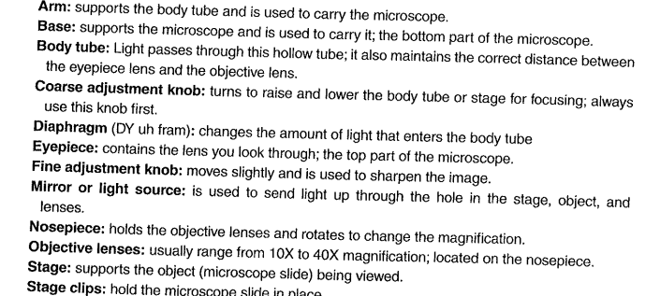
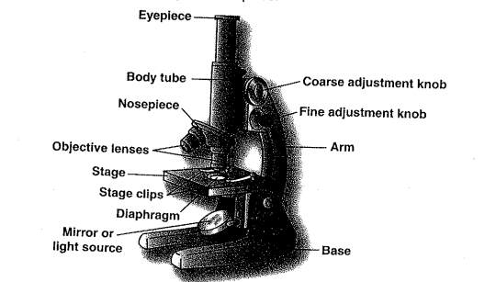

Label the Parts of the Microscope

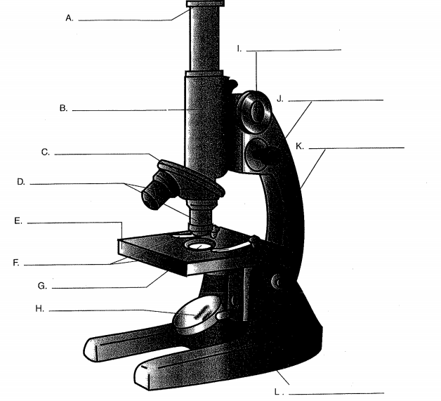

Preparing a Dry Mount Specimen

Purpose: to become familiar with the basic features and the operation of a compound microscope.

Materials: microscope slide scissors
Tweezers newspapers

Procedure:
  - Obtain a microscope and a slide. Cut a lowercase “e” from a newspaper and place it in the center of the slide. In your notebook, describe its appearance.
  - Hold a cover slip at an angle of 45 to the side and gently lower it over it over the newspaper letter. Place the slide on the microscope stage with the letter “e” right side up. Use the stage clips to hold the slide in position,
  - With the low-power objective lens in place, look through the ocular lens and focus the coarse adjustment knob. On the sheet provided, prepare a drawing of the letter as you see it.
  - Looking through the ocular lens move the slide forward on the stage. Notice what happened to the “e” in your field of view.
  - Switch to medium power and focus using the fine adjustment knob. On the sheet provided, prepare a drawing of the letter as you see it now.
  - Repeat step 4 using the high power objective lens
  - Switch to low power and remove the slide. Clean the slide and cover slip a paper towel.

Analyze and Evaluate:
- What was the difference between the letter “e” viewed with your unaided eye and the letter as seen through the microscope?

- What happened to the letter “e” when you moved the slide forward on the stage? What happened to it when you moved it to the right? What can you conclude about the direction of movement see through the microscope in relation to the actual direction of movement?

- What went well for you during the experiment and what do you feel that you need to work on the next time you use the microscope?

- When in real life do you feel someone could use the skills of preparing a dry mount specimen to view under a microscope?

Dry Mount Observation Recording

________ X magnification

________ X magnification

________ X magnification

________ X magnification

LAB: Animal Cells – Human Cheek

Purpose:

The purpose of this activity is to view animal cells under a microscope, in order to gain a more clear understanding of the appearance of cells in multicellular animals.

Equipment:

• Microscope • Microscope Slide • Slide Cover
• Tweezers • Methylene Blue • Eye Dropper
• Toothpick

Procedure:

- Using a clean toothpick, gently rub the inside of your cheek – do not use the point to do so.

- Smear the toothpick along the center of your slide.

- Place a small drop of methylene blue on the smear.

- Place the slide cover, properly, over the smear.

5. Observe the cheek cells with the microscope.
a. Complete a drawing of the cheek cells at lower power, focusing on the layout of the cells – what shape are they, how do they fit together (tight/spaced), are they similar or different
b. Complete a drawing of a single cheek cell at high power, focusing on the components of the individual cell – can you see organelles

6. Label your slide with a marker, and save it for future viewing.

** Note: There are several safety precautions to consider:
• The skin on the inside of your cheek is soft, be very careful not to push too hard with the toothpick.
• Methylene blue is poisonous, keep it away from your mouth and wash your hands once you are done using it.
• Methylene blue will stain both your skin and your clothes, handle it carefully.

LAB: Plant Cells – Onion Skin

Purpose:
The purpose of this activity is to view plant cells under a microscope, in order to gain a more clear understanding of the appearance of cells in multicellular plants.

Equipment:

• Microscope • Microscope Slide • Slide Cover
• Tweezers • Iodine • Eye Dropper
• Onion • Knife

Procedure:

- Using the tweezers, peel off a single layer of onion skin from the inner curve of a layer of onion (if you cannot see through it, it is too thick).

- Carefully lay the onion skin on your slide, making sure to lay it flat, do not let it fold.

- Place a small drop of iodine on the onion skin.

- Place the slide cover, properly, over the onion skin.

- Observe the onion skin with the microscope.
a. Complete a drawing of the onion skin cells at lower power, focusing on the layout of the cells – what shape are they, how do they fit together (tight/spaced), are they
similar or different
b. Complete a drawing of a single onion skin cell high power, focusing on the
components of the individual cell – can you see organelles

6. Label your slide with a marker, and save it for future viewing.

***Note: There are several safety precautions to consider:
• The juice from an onion can sting your eyes, wash your hands when you are done handling it.
• Iodine is poisonous, keep it away from your mouth and wash your hands once you are done using it.
• Iodine will stain both your skin and your clothes, handle it carefully.
•

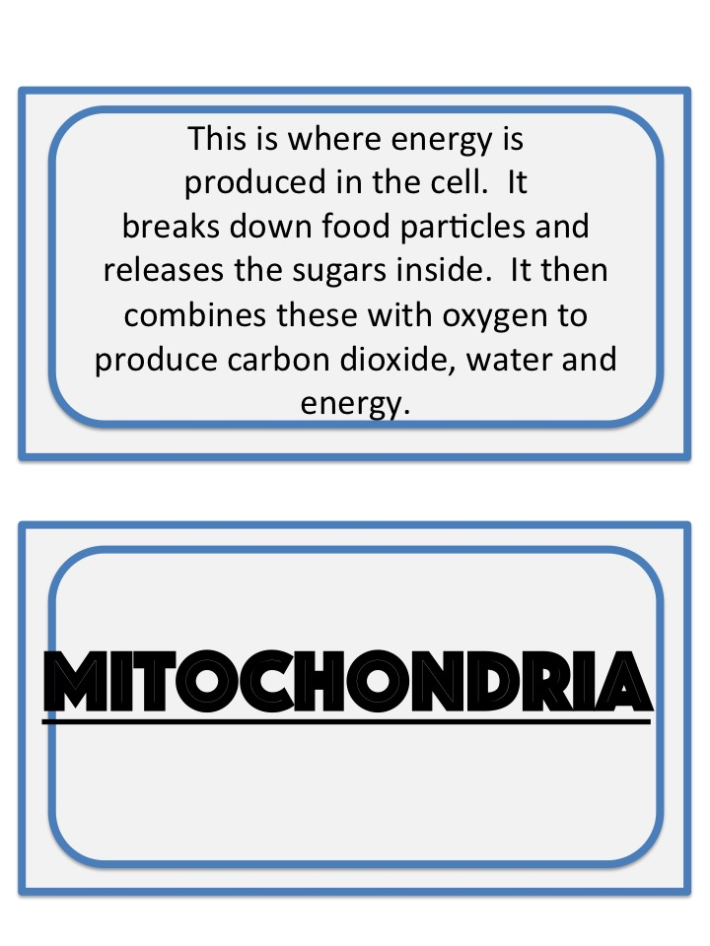

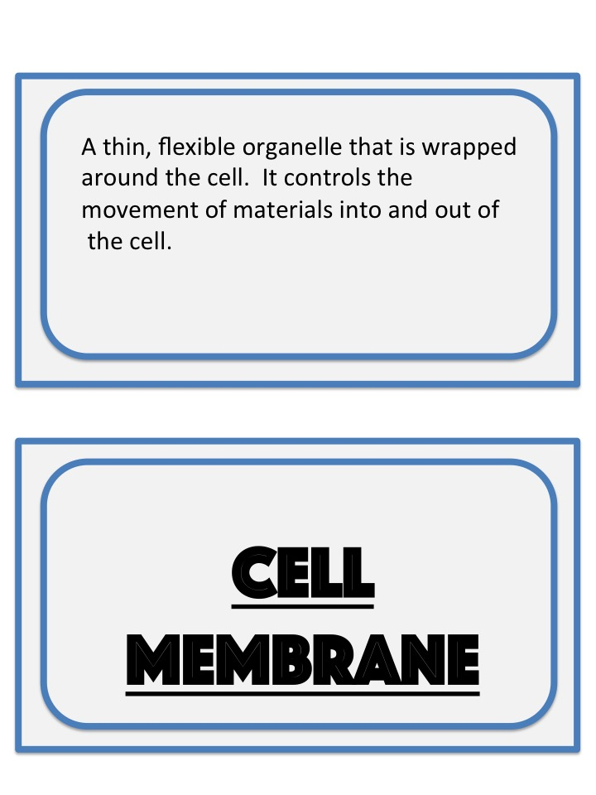
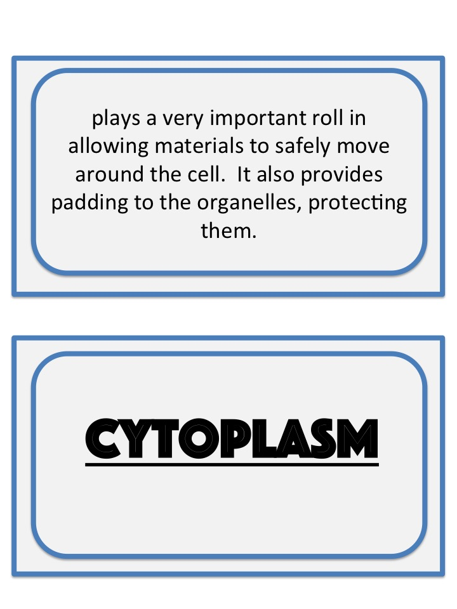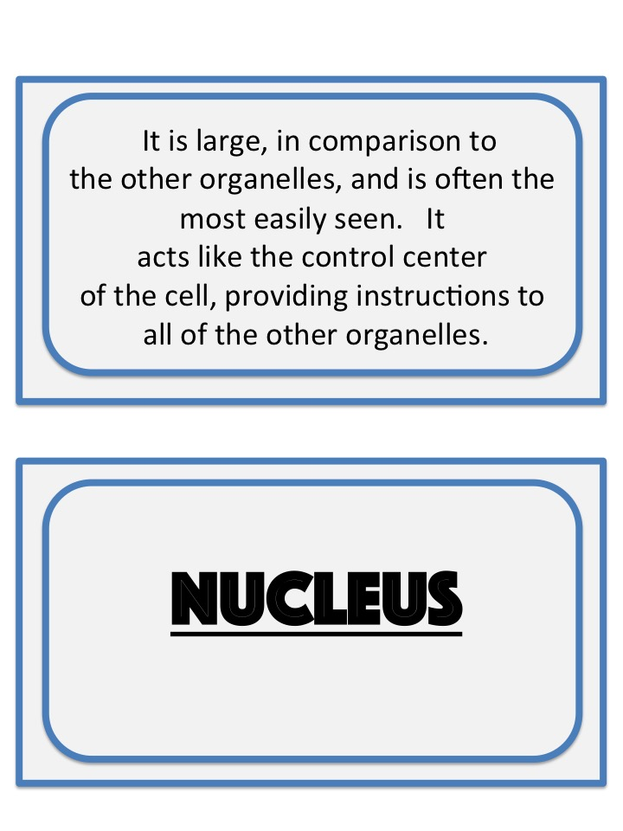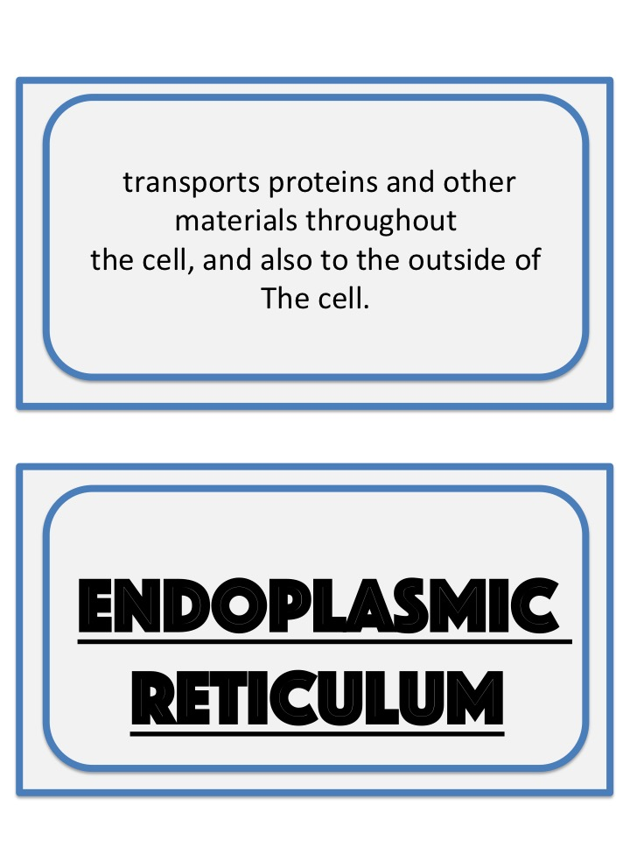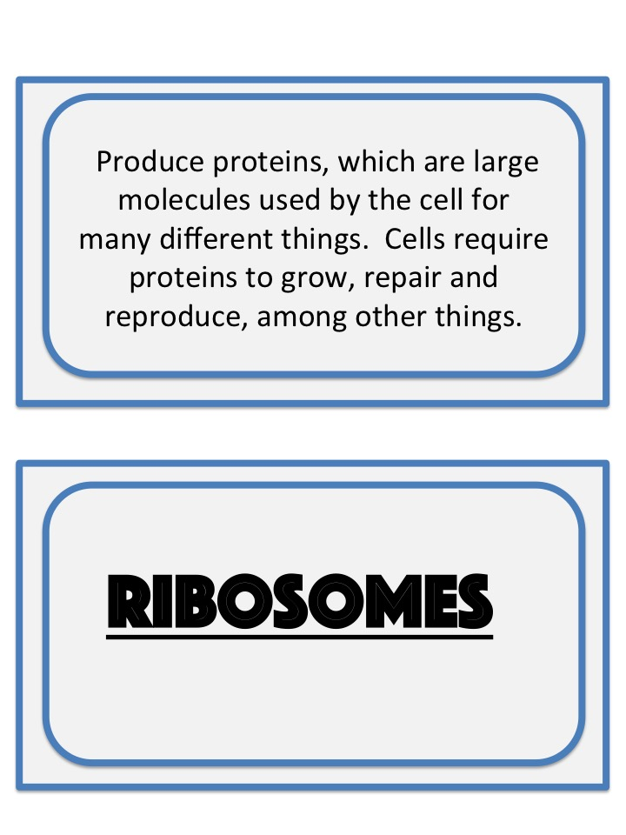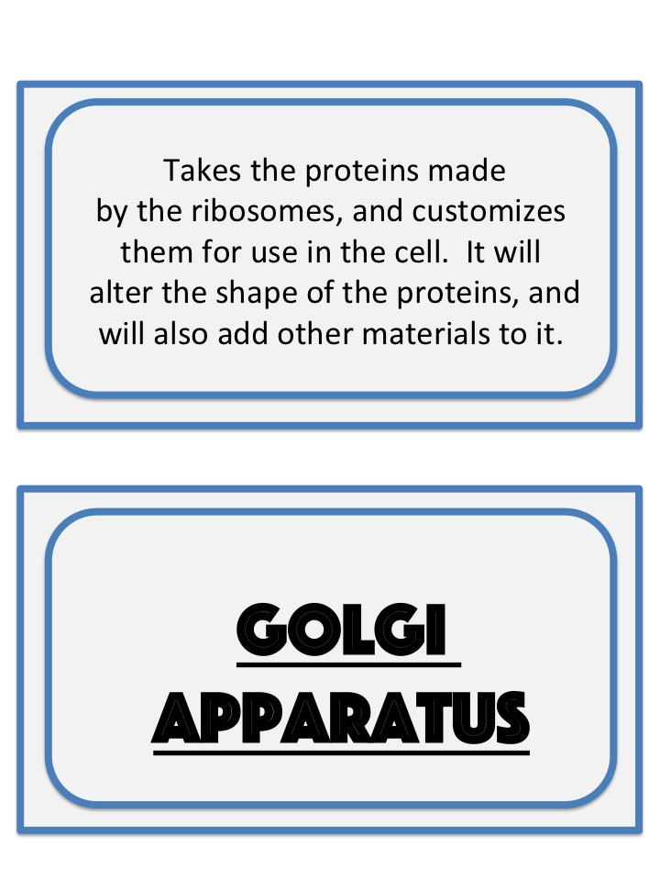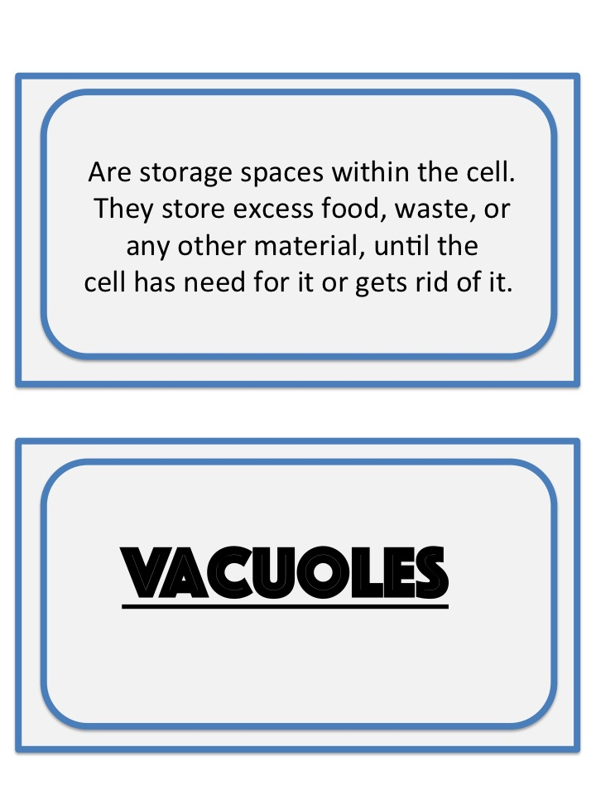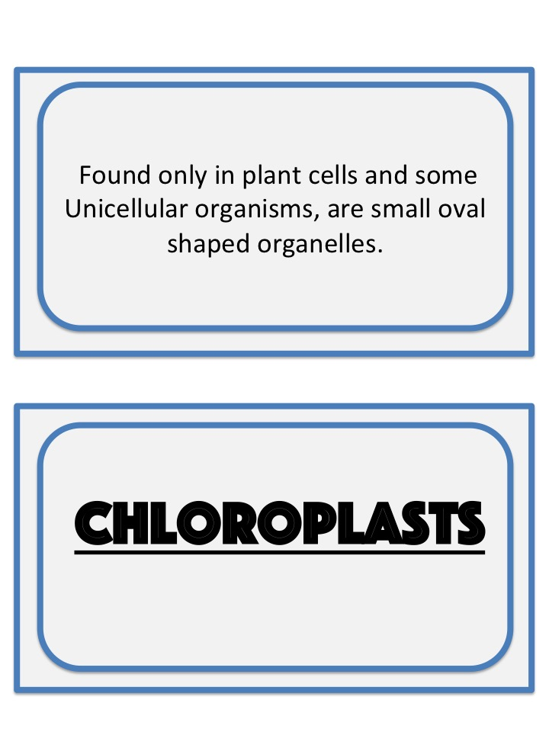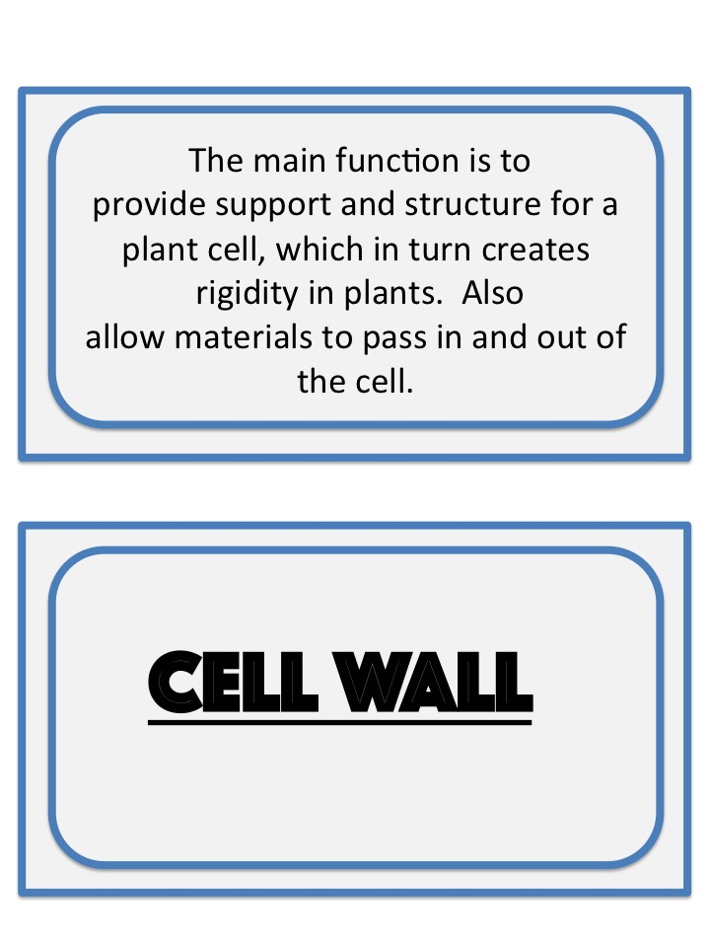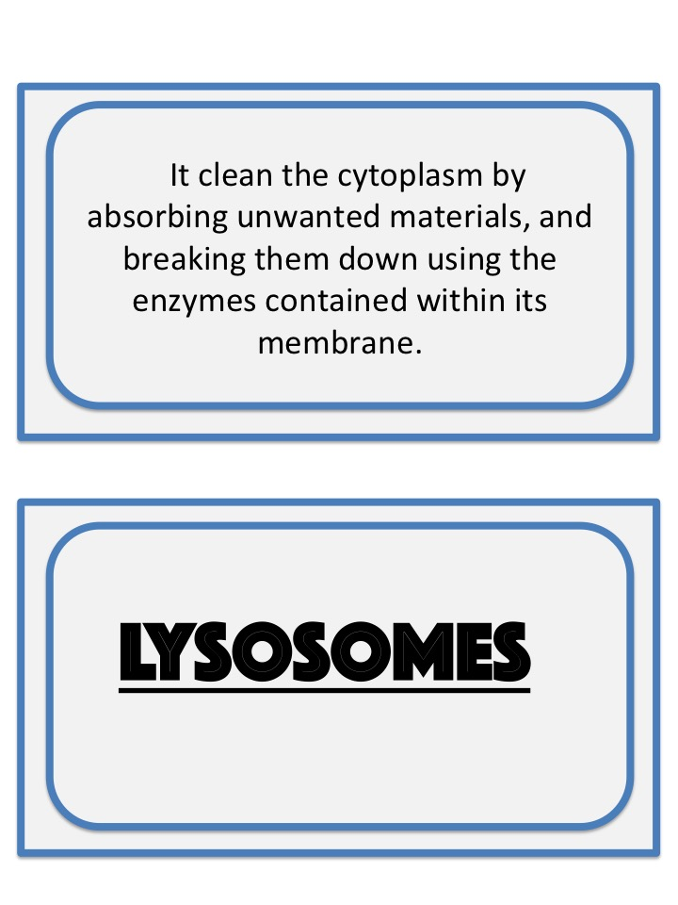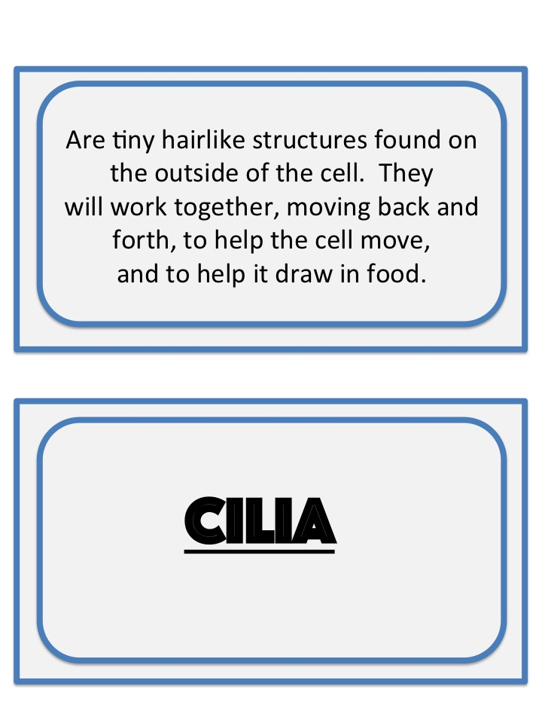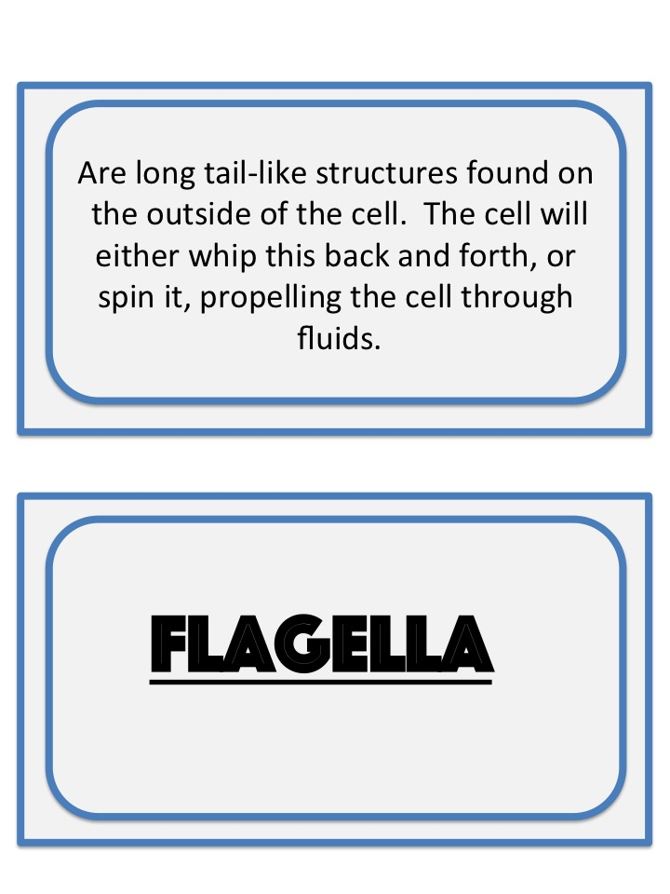

Cell Processes

Cellular processes are the activities that go on inside a cell that help an organism to survive. Some of these processes include creating energy, protein production, and even cellular destruction.

Cells take in food, oxygen, and other substances from their environments. They also release waste materials into their environments. A cell has a membrane around it that works for a cell like a window screen does for a room. A cell’s membrane is selectively permeable. It allows some things to enter or leave the cell while keeping other things outside or inside the cell. The window screen also is selectively permeable based on the size of its openings. Things can move through a cell membrane in several ways. Which way things move depends on the size of the molecules or particles, the path taken through the membrane, and whether or not energy is used. The movement of substances through the cell membrane with or without the input of energy is either called active or passive transport. Three types of passive transport can occur. The type depends on what is moving through the cell membrane. The three types of passive transport are: diffusion, facilitated diffusion and osmosis.

What is Diffusion?
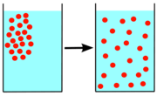
Molecules in solids, liquids, and gases move constantly and randomly. You might smell perfume when you sit near or as you walk past someone who is wearing it. This is because perfume molecules randomly move throughout the air. This random movement of molecules from an area where there is relatively more of them into an area where there is relatively fewer of them is called diffusion. Diffusion is one type of cellular passive transport. Molecules of a substance will continue to move from one area into another until the relative number of these molecules is equal in the two areas. When this occurs, equilibrium is reached and diffusion stops.

What is Facilitated Diffusion?
This involves large or charged molecules that need a protein helper to get in & out of the cell. Some molecules are too large to pass through the cell membrane by diffusion and need help to cross. These molecules use facilitated diffusion. Facilitated diffusion is the flow of large molecules from an area of high concentration to an area of low using proteins in the cell membrane. A glucose molecule is too big to squeeze through and needs protein channels to help it pass into the cell. These protein “helpers” are extremely important because they allow much needed molecules to enter our cells.

What is Osmosis?
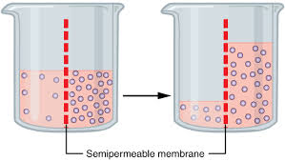
Remember that water makes up a large part of living matter. Cells contain water and are surrounded by water. Water molecules move by diffusion into and out of cells. The diffusion of water through a cell membrane is called osmosis If the solution outside a cell has a higher concentration of water molecules (pure water) than the inside more water diffuses into the cell than out. This causes the cell to swell. If a solution outside the cell has a lower concentration of water molecules (salt water, sugar water) than inside the cell more water will diffuse out than in. This causes the cell to shrink.
Note: Plant cells can take in more water than animal cells because of their strong cell walls.

Active and Passive Transport
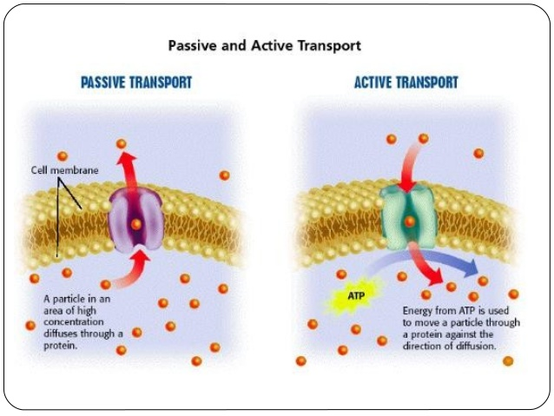
Active and passive transport are biological processes that move oxygen, water and nutrients into cells and remove waste products. Active transport requires chemical energy because it is the movement of biochemicals from areas of lower concentration to areas of higher concentration. On the other hand, passive transport moves biochemicals from areas of high concentration to areas of low concentration; so it does not require energy.

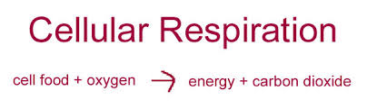
What is Cellular Respiration– The energy releasing process in both plants and animals is called respiration. Cellular respiration is the process in which the chemical bonds in energy-rich food molecules are broken apart and then converted into energy. In eukaryotic cells this takes place in the mitochondria. In the process the reactants glucose (sugar) and oxygen are converted into the products of carbon dioxide, water, and energy. Part of the energy released is in the form of a molecule that stores and transfers the energy within the cell.

Name: _________________ /11
Quiz
A Check for Understanding

1) What is it called when cells use energy to move molecules?
A) diffusion C) active transport B) osmosis D) passive transport

2) What occurs when the number of molecules of a substance is equal in two areas?
A) equilibrium C) fermentation B) metabolism D) cellular respiration

3) Which of the following substances is an example of a carbohydrate?
A) enzymes C) waxes B) sugars D) proteins

4) What organic molecule stores the greatest amount of energy?
A) carbohydrate C) lipid B) water D) nucleic acid

5) All chemical reactions in living things take place in what kind of a solution?
A. protein C. gas B. water D. solid

6) The carbon dioxide that you exhale is a product of
A. osmosis. B. DNA synthesis. C. photosynthesis. D. respiration.

7)Describe three ways a large or small molecule can cross the cell membrane. Explain your answer using vocabulary learned this unit.

8) Draw an example of Diffusion and Osmosis in the boxes below

Osmosis | Diffusion

Cell Respiration Reading
Individual cells operate very similar to our bodies or cars; on energy. Cells cannot not function properly without energy just as our bodies can’t function without food or our cars with out gas to fuel them. The chemical process of breaking down food in plant and animal cells is called respiration. When you hear the word respiration, you may be thinking of the act of breathing. Your cells use the oxygen that you breathe in and out to get rid of carbon dioxide and create energy. Respiration is the chemical reaction that happens in all living cells, including plant cells and animal cells. It is the way that energy is released from glucose or food we consume so that all the other chemical processes needed for life can happen.

What is Cellular Respiration?
Cells need energy to function. Cellular respiration is the process cells -- plant cells and animal cells -- use to make this energy. Cellular respiration is necessary to turn the food that is consumed into energy in order for a cell to grow and thrive. The formula below explains the chemical equation that takes place within the body.

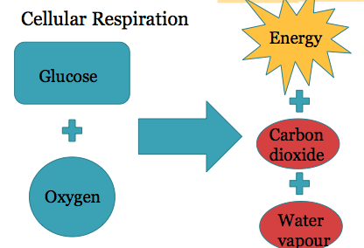

Powerhouse of the Cell
Cellular respiration takes place in the mitochondria. As a result of energy being produced in the mitochondria these organelles are often called the powerhouse of the cell. Your muscles for example contain several hundred mitochondria because they are frequently active and require lots of energy to function properly i.e contract when needed. Another example is nerve cells that require energy to send important messages throughout your body efficiently. Most other cells within the body require sufficient energy to grow and reproduce to keep the body optimally functioning.

How Cells Get Energy
Answer each of the questions to follow, in full sentences. Use the provided reading as a reference to compose your answers.

- What is energy?

- What organelle makes energy in a cell?

- What is the name given to the process that releases food energy?

- Write the word equation for the chemical reaction of cellular respiration.

- Why would you expect to have many mitochondria in a muscle cell?

- Besides “powerhouse,” can you think of other words that describe mitochondria?

- Name some of the processes for which cells require energy

- Two special cells are listed below. How does each of these cells use energy?
  - Muscle Cells:

b. Nerve Cells:

Mitosis

Lets think back to the cell theory we learned at the beginning of this unit. The third statement was that all cells come from pre-existing cells. This idea means that everything comes from something. Or in simpler terms; reproduction. We know in human reproduction a single sperm cell and an egg cell come together to reproduce an offspring of the two. These two cells go on to create almost 37.2 trillion, or 37 200 000 000 000 cells in what becomes a new human body.

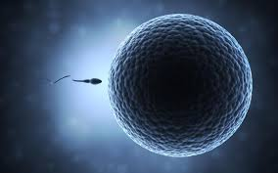
This fact becomes more incredible when you simplify this question: How many cells is an organism made from initially? One!

All organisms start as a single cell, a fertilized egg, which will split into 2, then 4, 8, 16, 32 etc. By doubling in this fashion it would take over 45 generations of cells to get to 37 trillion. This, however, does not account for the loss of cells.

When a fertilized egg is growing, initially all of the cells are the same. However, as it
grows, the cells begin to change, and become specialized cells. As the organism grows,
there is no longer a doubling process, but cells begin to divide so that they can replace
damaged cells. For example, your red blood cells have a rather shortlife, a human body
produces approximately one million new red blood cells every second, and in a matter of months, every red blood cell in your body is replaced. On the opposite end of the
spectrum are the cells found in your brain. Brain cells will last your entire lifetime, so once you are fully grown, there are no new cells being produced. This is why diseases,
such as Alzheimer, are difficult to manage.

Compared to the cells in a human body, some cells reproduce at a very fast pace.
Some bacteria have been found to reproduce as quickly as 20 minutes.

So, why is it that we need cells to constantly reproduce?There are a few reasons as to why new cells are needed.

Firstly, new cells are needed in order for an organism to grow. Cells can grow, but that growth is limited. In order for an organism to get larger, it requires more cells. Another reason that cells reproduce is to replace damaged cells. There are several things
that can damage cells, including physical contact, heat, or a lack of necessary resources
(oxygen, nutrients).If a cell becomes damaged, the organism will get rid of it, break it
down and replace it. One result of damaged cells not being replaced is known as: Cancer.

As humans, we see evidence of cells replacing themselves. When we get a cut the

tissue needs to be healed. Over time new skin tissue will replace the damaged tissues. Some organisms see this process in much more extreme situations. Some species are capable of something called regeneration. Lizards are capable of regrowing their tail if it is
taken off by a predator (some can purposely "drop" their tail). Lobsters can even grow
new legs if they were to lose one.

As biology advances, scientists have looked into ways of using animal DNA to help humans to regrow limbs. So, the question is, just how does a cell reproduce?

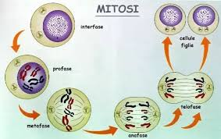
The process that cells undertake is known as Mitosis.

1.The DNA starts to form into two sets of identical chromosomes on the inside of the
nucleus

2. The nuclear membrane starts to dissolve

3. Parts, known as "spindles" attach to the chromosomes

4. The chromosome pairs are pulled apart

5.New nuclei start to form, all other parts from the cell are divided between the two
halves

6. The cell membrane pinches closed in the middle

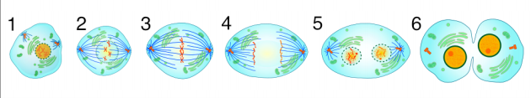

Drawing Mitosis

Cellular Reproduction
Answer each of the questions, in short form, based on our in-class conversation.

1. What is the third postulate of the Cell Theory?

2. Approximately how many cells are in a human body?

3. How many cells are in an organism initially?

4. What disease is a result of brain cells not being replaced when they die?

5. How quickly can some bacteria reproduce?

6. Name two reasons (as discussed) as to why cells would need to reproduce.

7. What disease is a result of damaged cells not being replaced, and allowed to reproduce?

8. Name the process that allows some organisms to replace parts.

9. What is the process called when a cell divides into two?

10. During this process, what comes from the nucleus, doubles and gets pulled apart.

Cell Mitosis flipbook

Students use a combination of their note, class readings and found research of Mitosis into a flipbook.

Mitosis CUT MITOSIS BOXES | interphase
 | PROPHASE
 | Anaphase
 | telophase
 | cytokinesis

Mitosis GLUE HERE | 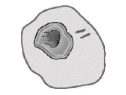
 | 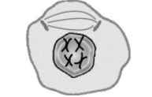
 | 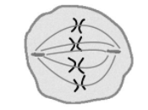
 | 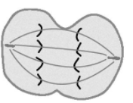
 | 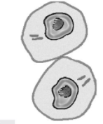

Cells and Cancer
Article

Cell division is essential for body growth and repair. What happens if cells begin to multiply and spread in an uncontrolled way? That is what happens in the bodies of people with cancer. Cancer cells divide at a far greater rate than normal cells and they spread to other parts of the body. Cancer has been described as “mitosis gone wild.” As the abnormal cancer cells continue to multiply, they spread to other parts of the body and damage them. Cancer is one of the leading causes of death in Canada today.

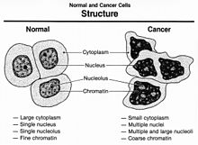
Cancer can affect many parts of the body and may be caused by many different factors. Factors that produce cancer are called carcinogens. They include some types of chemicals, radiation, inherited (genetic) factors, certain viruses, and repeated damage to the body.

People working in some jobs may be exposed to particular types of carcinogens. For example, people working in industries using asbestos have had high rates of lung cancer because they inhale fine particles of this substance over long periods of time. Some farmworkers have had high rates of cancer after improperly using certain pesticides. The rates of industry-related cancers have been reduced by use of protective clothing, air filters, and banning some harmful chemicals.

Some cancers can be prevented by changing lifestyle habits to reduce exposure to carcinogens. One example is the link between smoking and lung cancer. Smokers are far more likely to die of lung cancer than non-smokers and they can reduce this risk by not smoking. Another example is the connection between sun exposure and skin cancer. People who spend many hours in the sun without protective clothing or sunblock have a high risk of developing skin cancer, caused by ultraviolet radiation from the sun. The incidence of skin cancer in Canada is on the rise. About 8000 cases of skin cancer are diagnosed each year in Canada.

Although prevention is better than cure, there are some treatments that can slow or stop the spread of cancer in patients who already have the disease. The techniques consist of destroying the cancerous cells while leaving normal cells intact. This can be done by chemicals (chemotherapy) or by radiation treatment – using high-energy particles to kill cells. These treatments are most successful if the cancer is diagnosed in an early stage, before the abnormal cells have spread widely through the body.
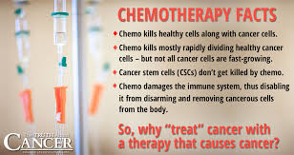

New techniques may give better methods of curing cancer in the future. One method is gene therapy, the altering of genes that cause cells to divide and produce cancer. Alternative therapies focus on ways to boost the body’s own natural immune system. For example, people may be able to use vaccines or drugs that stimulate their bodies to destroy cancer cells, making them immune to cancer.

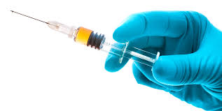

Name: ________________

Investigating Cancer and its Causes

Answer each of the questions to follow. Use the provided reading as a reference to compose your answers.

1. What is cancer?

2. What do you think is meant by the expression “cancer is mitosis gone wild”?

3. What is a carcinogen?

4. What are some examples of carcinogens?

5. How might someone become exposed to carcinogens?

6. What is one strong link to getting lung cancer?

7. What is one form of cancer commonly diagnosed in Canada?

8. What are some recommendations to prevent this type of cancer?

9. What is chemotherapy?

10. Why do you think it is important to visit your doctor regularly?

11. Why is research so important to cancer patients?

12. What are some research techniques that might become popular in the future?

The Cells That Make Us
By ReadWorks

“Mom, I’m hurt,” said Mike. “What happened?” asked Mike’s mom.

“I stumbled and fell while playing football at the playground today. I scraped my knee,” said Mike.

“You poor dear. Here, let’s put a Band‐Aid on your knee,” said his mom. Mike’s mom gingerly wiped his bleeding knee with a wet cloth and pasted a Band‐Aid on it. Mike wondered aloud, “Our bodies are made of arms and legs. The arms and legs are made of blood and bones. But what are these blood and bones made of?”

Mike’s mom replied, “Everything in our body is made of small units called cells. Think of it this way. Just like hundreds of thousands of bricks form a house, millions of cells form our blood, muscles, bones, skin, and hair—eventually coming together to form the human body.”

As Mike looked at his bandaged knee, he wondered, “Wow, can I see these cells?”

“You cannot see your cells directly,” said his mom. “A cell is tiny and is as small as the bacteria and other microorganisms that we cannot see with our naked eye. A cell is the smallest unit that can be said to be alive. You can see a cell if you have a powerful enough microscope, just like you’d see bacteria or microbes under a microscope.”

“So, every part of my body consists of cells?” Mike said.

“Yeah. Not just your body, mine too,” said Mike’s mom. “Your pet dog, Tommy? He’s made of cells. Your friend Jim’s cat? She’s made of cells, too. The lions we saw on safari last year, the spiders in our storeroom. Every creature on earth is made of tiny cells, just like you and me.”

“Wow, so an ant or an amoeba is built up of cells, like so many Lego blocks?”

“Yes, just like Lego blocks. Only some creatures have just a single cell, like an amoeba. They are called unicellular organisms. Others, like us human beings, are collections of cells. These are called multicellular organisms. Multicellular organisms can range in size from brown algae to large animals like elephants, whales, and giraffes, which have trillions of cells.”

“But what does a cell look like?”

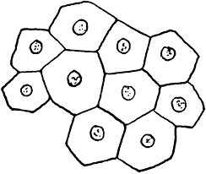
“A cell is tiny, of course. But if you did manage to peer into a cell with a microscope that was powerful enough, you could see that a cell consists of different parts, too.”

“So what parts are these?”

“Just like parts of our body are responsible for different activities (legs for movement, stomach for digestion, eyes for seeing, etc.), different parts within cells are responsible for different functions. These different parts perform the activities that keep the cell alive.”

“Wow, so how does this teeny weeny cell stay alive?”

“The different parts of the cell work together to keep the cell alive. The nucleus is the ‘brain’ of the cell. It controls and coordinates all activities of the cell. The nucleus is surrounded by the nuclear membrane, which is like a blanket that protects the nucleus. The cell membrane is the outer covering of the cell, much like the nuclear membrane is the covering of the nucleus. The cell membrane is like a tap which controls what enters and leaves the cell. It can allow certain substances(food and water) to enter the cell, and block out other substances(waste or poisonous substances).”

“So the cell membrane is like a sieve that lets in some things and blocks other things?”

“Yeah. Or like an electric switch, if you think of it that way. Then there is the cytoplasm, which is a jellylike fluid that fills the cell, much like blood fills our body.”

“Or like air fills the atmosphere around us?”

“Exactly! Only, all of this is within the tiny cell you can only see with the help of a microscope.”

“Wow. This is like a tiny machine!”

“Yeah. But that’s not all. All plant, fungal and some animal cells also have vacuoles, which is a cavity that works like a storage container.”

“And what goes inside it?”

“It depends. Mostly, vacuoles are used to isolate harmful and waste material from the rest of the cell and help get rid of it.”

“And what else?”

“Water; in plants, vacuoles help maintain the right water pressure. Animal cell vacuoles also help to store fats, starches, and glycogen which are all energy products.”

“Is energy produced inside the vacuoles too?”

“No. Energy production happens in a part of the cell called the mitochondrion. These mitochondria are shaped like kidney beans. They convert food into chemical energy for the cells.”

“And all the millions of cells keep me alive.”

“Absolutely. With the accumulated energy in every one of the millions of cells, you and I get the strength to move our arms and legs, to think, move about, and to live.”

“Wow. But each cell is tiny, so each cell would produce only a tiny amount of energy.”

“Yeah. So these cells have to work together. A group of cells band together and form a tissue. There are many types of tissues. For example, connective tissues include blood or bones. These form connections between parts of the body. Muscle tissues form muscles, which help us move. Nervous tissues help parts of our body transmit messages—or ‘think’ and react to things that happen around us. Epithelial tissues are outer tissues that form protective layers.”

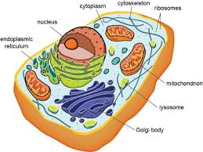
“Like, skin?”

“Exactly! These tissues are specialized for different functions, so they work together in unison. For instance, all the cells in the muscle tissue in your calf muscles work together so that you can walk or run.”

“…and the tissues in my biceps help me wave my hand,” said Mike, waving his hand from side to side.

“That’s not all,” said Mike’s mom. “Often, tissues cannot function or operate by themselves. So, these tissues team up to form organs.”

“Just like me and my friends together form a football team,” said Mike, reminded of his scraped knee.

“Yeah, just like you can’t play football by yourself, a tissue cannot do anything by itself. It teams up with other tissues, and together, they perform the body’s activities. So, a group of tissues team up to form your nose and help you smell. Other tissues in your pancreas help you digest food. So, each organ performs its specific function because of the tissues that constitute it.”

“And the tissues, of course, are formed by the teeny weeny cells. Wow, so even if a cell by itself cannot smell anything, or a tissue by itself cannot smell anything, a collection of tissues can actually smell? That is so cool!”

“Unless you’re a unicellular organism, one cell can’t do much on its own. But in unity, there is strength. When millions of cells work together, magic happens. When cells combine to become tissues and tissues combine to become organs, the organs can perform the everyday activities like digestion, breathing, smell, taste—and just about everything else you do.”

“Wow, all because of a teeny weeny cell! That is truly magical.”

Name:_______________________

Reading Comprehension

1. According to Mike’s mom, what is a cell?

A another name for an amoeba
B the smallest unit of life
C a group of tissues
D a jellylike fluid

2. How does Mike’s mom compare the nuclear membrane and the cell membrane?

A Both the cell membrane and nuclear membrane are protective coverings.
B The cell membrane is like a blanket, while the nuclear membrane is like a sieve.
C The nuclear membrane is like an electric switch, while the cell membrane is like
a sieve.
D Both the cell membrane and the nuclear membrane allow substances to enter
the cell.

3. Read the following sentences from the passage: “‘Only some creatures have just a
single cell, like an amoeba. They are called unicellular organisms. Others, like us human
beings, are collections of cells. These are called multicellular organisms. Multicellular
organisms can range in size from brown algae to large animals like elephants, whales,
and giraffes, which have trillions of cells.”

What can be concluded about cells based on this information?
A Unicellular organisms were once part of collections of cells.
B Cells in multicellular organisms are stronger than unicellular organisms.
C Cells can only support life if they are part of a multicellular organism.
D Some cells can support life independently. Other cells support life collectively.

4. Read the following sentences: “A group of cells band together and form a tissue.
There are many types of tissues. For example, connective tissues include blood or
bones. These form connections between parts of the body. Muscle tissues form muscles,
which help us move. Nervous tissues help parts of our body transmit messages—or
‘think’ and react to things that happen around us.”

Based on this information, what can you conclude about tissues?
A All tissues in the body have similar functions.
B All tissues band together to form organs.
C Each kind of tissue has a different function.
D There are only four kinds of tissues in the human body.

5. What is this passage mostly about?

A how the parts of the cell, tissues, and organs work together
B the importance of mitochondria in the life of a cell
C how tissues are made from groups of cells to serve different functions
D the differences between unicellular and multicellular organisms

6. Read the following sentences: “Just like you can’t play football by yourself, a tissue
cannot do anything by itself. It teams up with other tissues, and together, they perform
the body’s activities. So, a group of tissues team up to form your nose and help you
smell. Other tissues in your pancreas help you digest food. So, each organ performs its
specific function because of the tissues that constitute it.”

As used in this sentence, what does the word “constitute” most nearly mean?
A take away from something
B give something energy
C make up the parts of something
D change in shape or size

7. Choose the answer that best completes the sentence below.
__________ a tissue by itself cannot digest food, a collection of tissues can work
together as an organ to digest food.

A Thus
B Although
C Above all
D For instance

8. Why do tissues “team up” to form organs?

Bill Nye: Cells ​ ​
This video can be accessed via YouTube

1. Organisms have many different kinds of cells to do different ​ ​ ​

2. Why are humans more like animals than plants? ​

​ ​ ​3. ____________________________________________ is when more cells are made than die off. ​

​4. Bill says that ALL cells have a nucleus, but we know that some cells, like ​____________________ ​cells have NO nucleus. ​ ​

5. Mitochondria in cells are like a fireplace, they provide ____________________.

​ ​6. ___________________________ is the process of 1 cell becoming 2 cells.

​ ​7. __________________________________are the road maps for cells and tell the cells what to do.

​ ​8. _____________________ is our bodies fastest growing organ because we shed millions of these cells every day. ​

​9. Humans have _________________ pair of chromosomes.

​10. Red blood cells are red because the _________________________ in the cell mixes with the ______________________ that we breathe in.

11. What is the only type of human cell that is never replaced? ​____________________________​ ​

