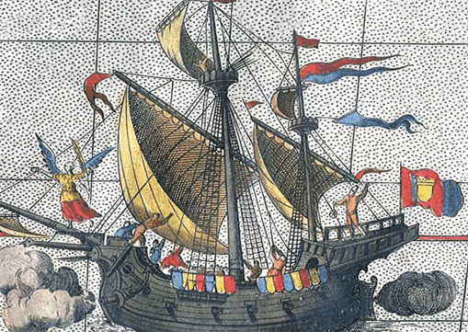
Age of Exploration Activity

You are an aspiring explorer and you are looking for financial support to finance your next voyage.

Your job is to create a presentation that you will use to convince a King, Queen or company that it would be in their best interest to sponsor you in this venture.

Your presentation must include the following:
1. Clearly display the reasons why exploration could benefit European Countries.
2. Indicate how Sea travel has improved (new technology).
3. Use a historical example that shows how a country benefited from exploration.
4. Present information in away that clearly argues the benefits of your venture.

How you choose to present the information is up to you! Some suggestions are:
Powerpoint Poster Video Cartoon

Resources: Our Canada (pages 39-47 & 71-72)
Reasons for Exploration (Age of Exploration Post)
Mariners' Museum Website (Age of Exploration Post)

