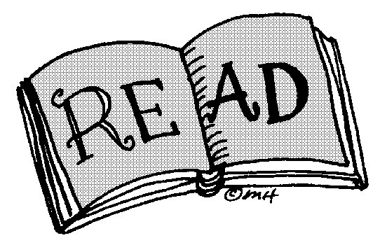
Independent Reading Assignment

This month you will have some choice for your reading package. Select Four activities from the list below to complete this month on the novel you are currently reading. Each entry should be 1 page in length. Time manage yourself to complete one selection a week.

Post reading activities:

1. Write a different beginning to your story

2. Write a different ending

3. Be a TV or radio reporter, and give a report of a scene from the book as if it is happening "live"

4. Choose a quote from a character. Write why it would or wouldn't be a good motto by which to live your life

5. Write about one of the character's life twenty years from now.

6. Add another character to the book. Why would they be put there? What part would they serve?
7. Tell 5 things you learned while reading the book

8. Make a timeline of all the events in the book

9. Write a diary that one of the story's main characters might have kept before, during, or after the book's events.

10. Give a sales talk, pretending the students in the class are clerks in a bookstore and you want them to push this book.

11.Write a letter to a character in the book.

12. Write a letter to the author of the book.

Independent Reading Rubric
 | Level 1 | Level 2 | Level 3 | Level 4
Ideas/Content  Does your work reveal that you have thoroughly read the novel and you understand the elements within the novel? | demonstrates poor comprehension of text excluding details from the text and no examples of setting, events characters, and literary elements | demonstrates limited comprehension of text using details from the text missing examples of setting, events characters, and literary elements | demonstrates comprehension of text using details from the text and includes some examples of setting, events characters, and literary elements | demonstrates excellent comprehension of text using details from the text and includes examples of setting, events characters, and literary elements
Reading Strategies  Do you make clear connections between the novel? Do you specifically reference the novel, make, predictions, infer happenings and/or summarize the main details? | Demonstrates no thoughtful analysis. Lack of inferencing and connections to story.  Developing reading strategies. | Demonstrates a somewhat thoughtful analysis; some connections made. Limited inference to story elements.  Limited use of reading strategies. | Demonstrates some insight and thoughtfulness in analysis. Connections are evident. An effort to infer and relate to characters and situations is evident.  Good use of reading strategies | Demonstrates very insightful and thoughtful analysis; connections are very relevant and clearly communicated. A, strong ability to infer, relate to characters and situations. Strong use of reading strategies.
Sentence Structure/  Conventions  Does your written work communicate clearly and effectively? Is your writing detailed? Do you use appropriate grammar, spelling, and punctuation? | Organization is not clear. Sentences are repetitive and nonsensical. Lack of editing is distracting to reader. | Limited organization is evident. Sentences are repetitive and lack fluidity. Lack of consistent editing is distracting to the reader. | Some organization is evident. Sentences are well written and non repetitive. Only minor editing oversights | Organization is very clear. Sentences are thoughtful, non repetitive and of high quality. Spelling and conventions have been effectively edited.
Creativity  Do you use personal creativity?Do you add your own interest and flare to the assignment? Have you put in a lot of thought and care? | There is little evidence of creativity in the project. The creator does not demonstrate much imagination. | contains some creative details and/or descriptions, but they distract from the project. The creator has tried to use his imagination. | contains adequate creative details and/or descriptions that contribute to the viewers enjoyment. The creator has used his/her imagination. | contains many creative details and/or descriptions that contribute to the viewers enjoyment. The creator has really used his/her imagination.

