Infographic Assignment

Examples:
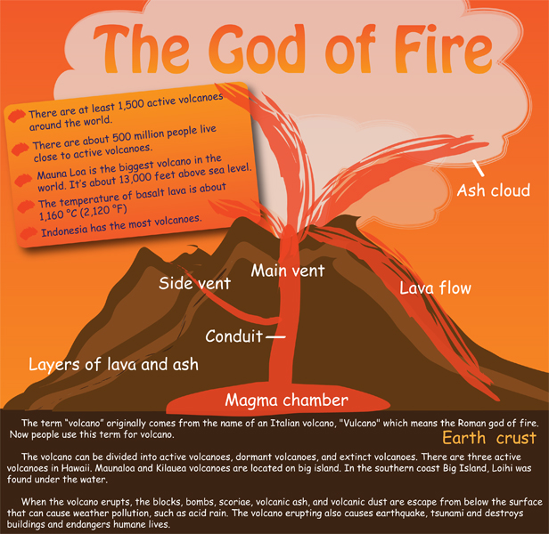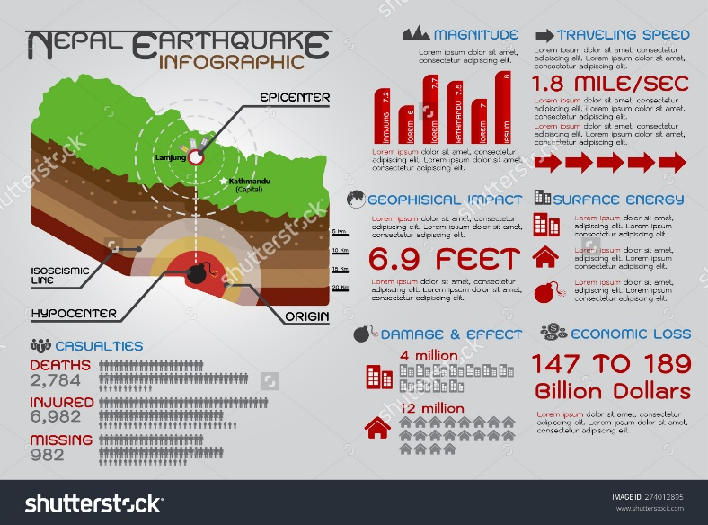

Criteria for Infographic
Your infographic must include:
1. A headline (main point) related to the content.
2. A short text summary explaining WHAT the infographic is showing
3. A chart or graph of some sort depicting information (supporting statistics/facts).
4. Graphic objects/pictures/clip art/shapes that support the content and/or help the viewers to understand how to read the infographics (arrows, circles, squares, etc).

Process
1. Use the internet, textbooks, or any additional information you have learned in class to choose ONE natural disaster of your choice. Select key points and statistics that will be included in your infograph.
2. Spend some time planning out your infographic on paper – ideally, what you want it to look like, given the above requirements. The more planning you do, the easier it is to create.
3. Make sure to include statistics and facts along with pictures/graphs/flow charts to make it visually interesting and easy to understand.
4. Be sure to frequently save you work by clicking “file” at the top of the page and “save”
5. When you are finished, click “publish” and save your infograph as a “.jpg” (it should automaticallysave to your downloads).
7. Print or Email your .jpg infograph to your teacher via googledrive.

