Halloween Haunted Houses

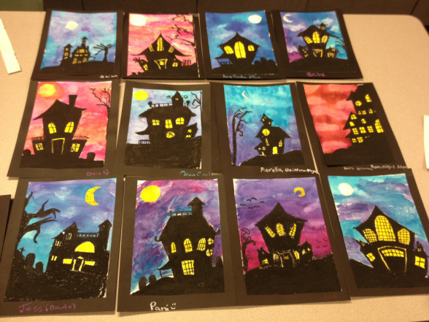

Steps
Look at examples of houses. Start with the basic shape, a rectangle or square. Then they could choose a triangular or rectangular roof. I showed them details they could add to the house; towers, a porch, a banister along the roof, etc. Then the windows and any details in the back ground, such as the moon, a tree, tombstones.
Next colour the moon and windows with yellow oil pastels.
Then start filling in the silhouettes with black oil pastel.
Now select two colours for the sky. When using watercolours you need a lot of water to make it work.
House