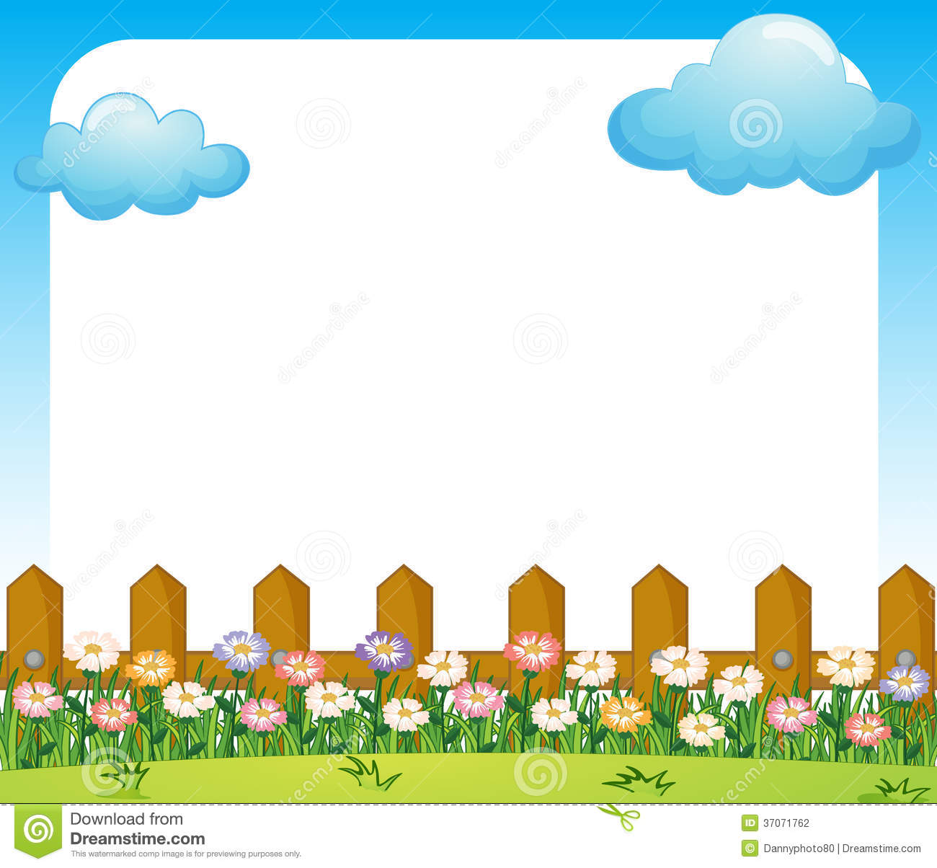

Thinking about what makes us happy is a great way to beat Stress. Draw what you like below. Then smile!

Feeling Flowers