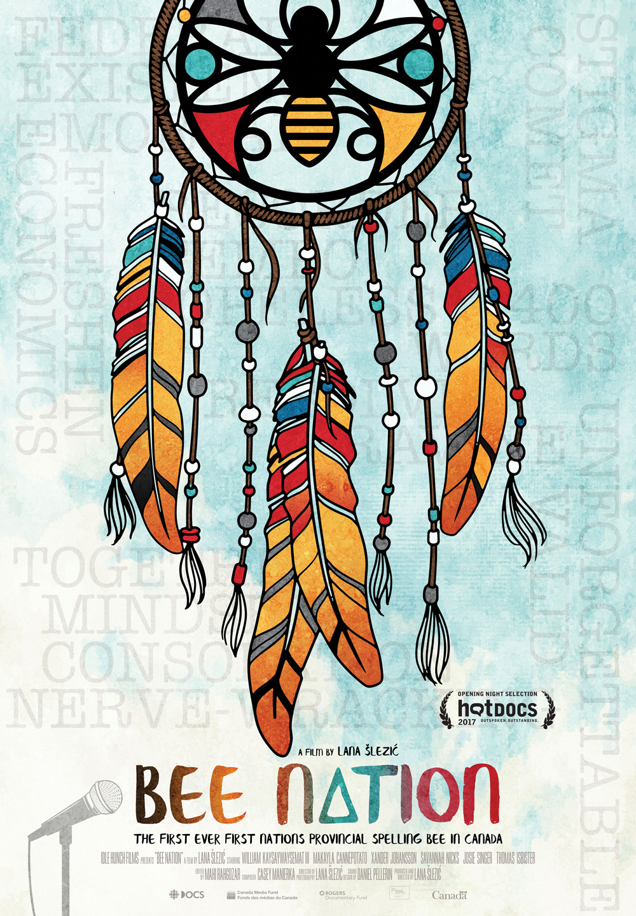
Bee Nation Documentary

Bee Nation highlights First Nation kids who have dedicated themselves to their education in an inspiring story that encourages us all to be our best selves.The young people featured in this film all live in the province of Saskatchewan, in on-reserve communities including the Ahtahkakoop First Nation, Big River First Nation, Saulteaux First Nation, Onion Lake First Nation and the Kakewistahaw First Nation. The documentary will shine a light on some drastic differences in lifestyle and educational opportunities between First Nation students and others around the Country.

Post Viewing Questions:

1) Does the film provide a complete understanding of the issues faced by First Nations youth living on-reserve? How does the filmmaker’s message affect students’ understanding of First Nations peoples and life in reserve communities?

2) Is racism and discrimination a factor for Indigenous peoples living in Canada today? How are racism and discrimination shown in this film?

3) Several of the young people in this film are being raised by their grandparents or by single parents. What are the issues faced by Indigenous families today? Are these issues the same or different from the issues faced by your own family?

4) Josie talks about what it’s like to live with 15 people in one small house. How have socio-economic conditions in your family or community affected your life and choices? How do you think they affect the life and choices of First Nations youth?

5) Before viewing this film, did Indigenous issues play a large part in your life and/or thinking? If yes, why? If no, why not? Whatever your answer, will this change now that you have seen this film? In what way? What did the film reveal to you that you did not know before? What did it show you that you had not seen or heard before?

Post Viewing Action

The documentary may have highlighted some issues that you weren’t aware of that First Nation communities are dealing with. Whether you viewed the film or not, students will research some of the issues in First Nations education. After conducting their search, Students will complete ONE of the following options:

- Create a poster to summarize the issues facing first Nation education today.

- Write a diary entry of one of the events from the film or an educational issue from the perspective one of the following i)First nation student ii) Non first nation student iii) Politician

- Write a 1 page summary that demonstrates what they learned from the film or their research, as well as one question that they still have about the topic.

First Nation Educational Issues Rubric

 | Level 1 | Level 2 | Level 3 | Level 4
Knowledge | Student demonstrates a limited understanding of the issues related to First Nation education and how to conduct a critical analysis, and does not include required information | Student demonstrates some understanding of the issues related to first nation education and how to conduct a critical analysis, and includes some of the required information | Student demonstrates a considerable understanding of the issues related to First Nation education and how to conduct a critical analysis, and includes most of the required information | Student demonstrates a thorough understanding of the issues related to First Nation education and how to conduct a critical analysis, and includes all of the required information
Connections | Student makes no connections with First Nation issues with limited effectiveness | Student makes some connections with First Nation issues with effectiveness | Student makes connections with First Nation issues with considerable effectiveness | Student makes many connections with First Nation issues with excellent effectiveness
Application | Student writing is not clear and final submission has many grammatical, spelling and punctuation errors. | Student writing is somewhat clearly and final submission is almost clear of grammatical, spelling and punctuation errors. | Student writing is clear and final submission is clear of grammatical, spelling and punctuation errors. | Student writing is very clear and final submission is clear of grammatical, spelling and punctuation errors.

